MSDS 460 Decision Analytics

Assignment 02

Brandon Moretz

Problem:

The marketing group of A.J. Pitt Company is considering the options available for its next advertising campaign program. After a great deal of work, the group has identified a selected number of options with the characteristics shown in the accompanying table.

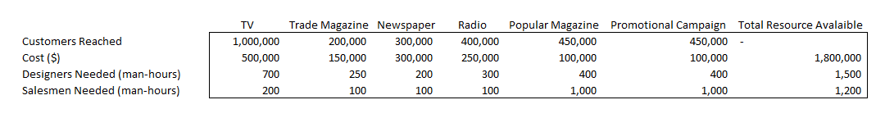

The objective of the advertising program is to maximize the number of customers reached, subject to the limitation of resources (money, designers, and salesmen) given in the table.

In addition, the following constraints must be met:

1. If the promotional campaign is undertaken, it needs either a radio or a popular magazine campaign effort to support it.
2. The firm cannot advertise in both the trade and popular magazine.

Formulate an integer programming model that will assist the company to select an appropriate advertising campaign strategy.

Solution:

**Decision Variables**:

Let,

Xi = be a binary variable.

Where,

Xi = 1, if i-th option is undertaken. The options are 1-TV, 2-Trade magazine, 3-Newspaper, 4-Radio, 5-Popular magazine, 6-Promotional campaign.

**Objective Function**:

Max Z = 1,000,000x1 + 200,000x2 + 300,000x3 + 400,000x4 + 450,000x5 + 450,000x6

s.t,

**Cost:**

500,000x1 + 150,000x2 + 300,000x3 + 250,000x4 + 250,000x5 + 100,000x6 <= 1,800,000

**Designers (man-hours):**

700x1 + 250x2 + 200x3 + 300x4 + 300x5 + 400x6 <= 1,500

**Salesmen (man-hours):**

200x1 + 100x2 + 100x3 + 100x4 + 100x5 + 1000x6 <= 1,200

**Promotional campaign conditional:**

X6 – X4 – X5 <= 0

**Trade or Popular magazine:**

X2 + x5 <= 1

**All binary constraints**:

Xi = 0, 1